**Online Store**

1. The main purpose of my project is to make an online store for clothes (like asos, forever 21 etc.) Customer makes an order online. Order might contain of a lot of clothes. Company will ship clothes to customer’s address. Manager will work with customer and get feedback on their work and online store in general from users. Therefore, I want my database to store information about clothes, companies, orders, customers, feedback managers, shipping. Their connection between each other is represented in ERD diagram.
2. create table orders (

id_order int,

o_sum int,

amount int,

primary key(id_order)

);

create table clothes (

id_clothes int,

c_type varchar,

model varchar,

c_size varchar,

amount int,

material varchar,

id_order int,

primary key(id_clothes),

foreign key (id_order) references orders(id_order)

);

create table shipping (

postalcode int,

country varchar,

city varchar,

primary key(postalcode)

);

create table customer (

id_customer int,

c_name varchar,

card int,

telnum varchar,

address varchar,

id_order int,

postalcode int,

primary key(id_customer),

foreign key (id_order) references orders(id_order),

foreign key (postalcode) references shipping(postalcode)

);

create table feedback (

id_feed int,

feedback varchar,

primary key(id_feed)

);

create table company (

id_comp int,

comp_name varchar,

address varchar,

postalcode int,

primary key(id_comp),

foreign key (postalcode) references shipping(postalcode)

);

create table manager (

id_manager int,

m_name varchar,

salary int,

working_days int,

id_comp int,

id_customer int,

id_feed int,

primary key(id_manager),

foreign key (id_comp) references company(id_comp),

foreign key (id_customer) references customer(id_customer),

foreign key (id_feed) references feedback(id_feed)

);

1. 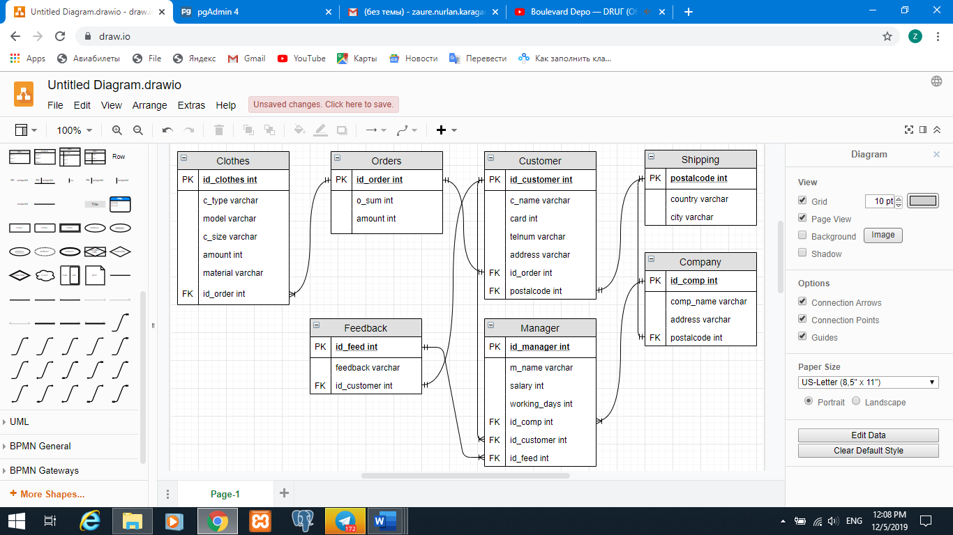

hires

receives

sends

asks

makes

gives

analyzes

Contain

1. create table store_owner (

owner_id int,

owner_name varchar

);

alter table store_owner

add primary key (owner_id);

alter table store_owner

alter column owner_name set not null;

drop column owner_name;

drop table store_owner;

alter table feedback

add column id_customer int;

alter table feedback

add foreign key (id_customer) references customer(id_customer);

1. insert into shipping (postalcode, country, city) values

(1000, 'Kazakhstan', 'Astana'),

(5000, 'Kazakhstan', 'Almaty'),

(8000, 'Kazakhstan', 'Taraz'),

(2000, 'Kazakhstan', 'Karaganda'),

(101000, 'Russia', 'Moscow'),

(15000, 'Kazakhstan', 'Karaganda);

Update shipping set country=’Russia’, city=’Piter’ where postalcode=11550;

Delete from shipping where postalcode=11550;

insert into company (id_comp, comp_name, address, postalcode) values

(1, 'Assel', 'Glushchenko', 1000),

(2, 'Mechanical Piano', 'Zapadnaya', 5000),

(3, 'AIKEN', 'Ul.shevchenko', 8000),

(4, 'Alima', 'Ploshchad Pobedy', 2000),

(5, 'Zherebtsov', 'Akademika Bekturova', 101000),

(6, 'Aliya', 'Abay', 15000);

Update company set comp_name= ‘Aliya Aliya’ where id_comp=6;

Delete from company where address= ‘Abay’;

insert into orders (id_order, o_sum, amount) values

(1, 2000, 10),

(2, 1000, 5),

(3, 500, 3),

(4, 3000, 12),

(5, 1500, 7),

(6, 6600, 11);

Update orders set o_sum=o_sum+400 where id_order=6;

Delete from orders where id_order=6;

insert into clothes (id_clothes, c_type, model, c_size, amount, material, id_order) values

(1, 'hoodie', 'slimfit', 'M', 25, 'cotton', 1),

(2, 'leggins', 'slimfit', 'S', 10 , 'polyester', 2),

(3, 'shirt', 'regularfit', 'L', 10, 'cotton', 3),

(4, 'coat', 'regularfit', 'M', 5, 'nylon', 4),

(5, 'dress', 'slimfit', 'S', 15, 'silk', 5),

(6, 'coat', 'regularfit', 'M', 6, 'nylon', 6);

Update clothes set c_type= ‘dress’ and c_size=S where id_order=6;

Delete from clothes where id_clothes=6;

insert into customer (id_customer,c_name,card,telnum,address,id_order,postalcode) values

(1, 'Zhanel', 101, '+7778745785', 'Ul.pospelova', 1, 1000),

(2, 'Aitugan', 102, '+77012366584', 'Serova 4', 2, 5000),

(3, 'Lyazzat', 103, '+77025879486', 'Ul.esenberlina', 3, 8000),

(4, 'Alisher', 104, '+77478925674', '2 Ambulatornyy Zaezd', 4, 2000),

(5, 'Marina', 105, '+77894567485', 'Mkr. Saltanat', 5, 101000),

(6, 'Alina', 106, '+77479529778', '2 Ambulatornyy Zaezd', 6, 2000);

Update customer set c_name= ‘Aliya’ and telnum=’+77019529778’ where id_order=6;

Delete from customer where id_customer=6;

insert into feedback (id_feed, feedback, id_customer) values

(1, 'Good service. Keep it up!', 1),

(2, 'I had got the wrong size', 2),

(3, 'The maretial feels so good on my skin!', 3),

(4, 'I am obsessed with my purchase!', 4),

(5, 'I did not get my order in 2 weeks. I think you should work on your shipping system', 5),

(6, 'It was amazing!', 6);

Update set feedback = ‘Amazing’ where id_feed =6;

Delete from where id_feed=6;

insert into manager (id_manager,m_name, salary,working_days,id_comp,id_customer,id_feed) values

(1, 'Kaisar', 150000, 3, 1, 1, 1),

(2, 'Otabek', 200000, 4, 2, 2, 2),

(3, 'Alikhan', 170000, 4, 3, 3, 3),

(4, 'Dimash', 300000, 6, 4, 4, 4),

(5, 'Zaure', 250000, 5, 5, 5, 5),

(6, 'Dima', 450000, 6, 6, 6, 6);

Update set salary= salary-50000 where id_manager=6;

Delete from where id_manager=6;

1. Unnormalized data

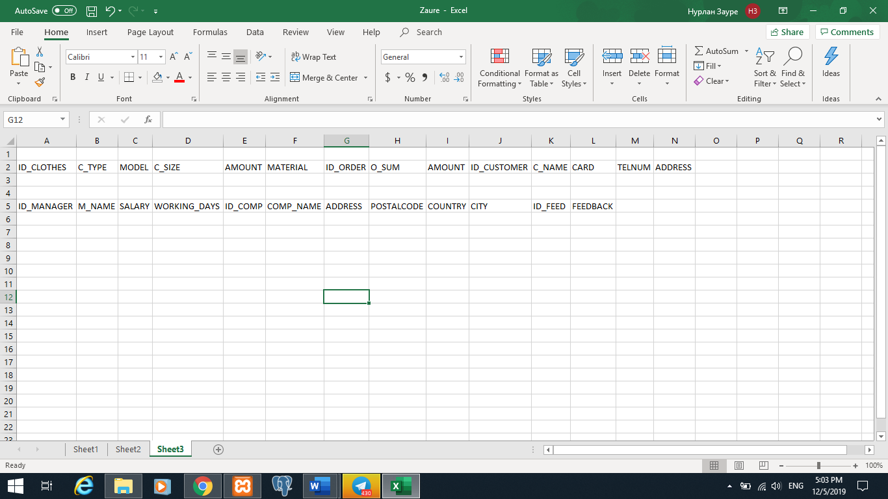

First Normalization

All data should be atomic.

Second Normalization

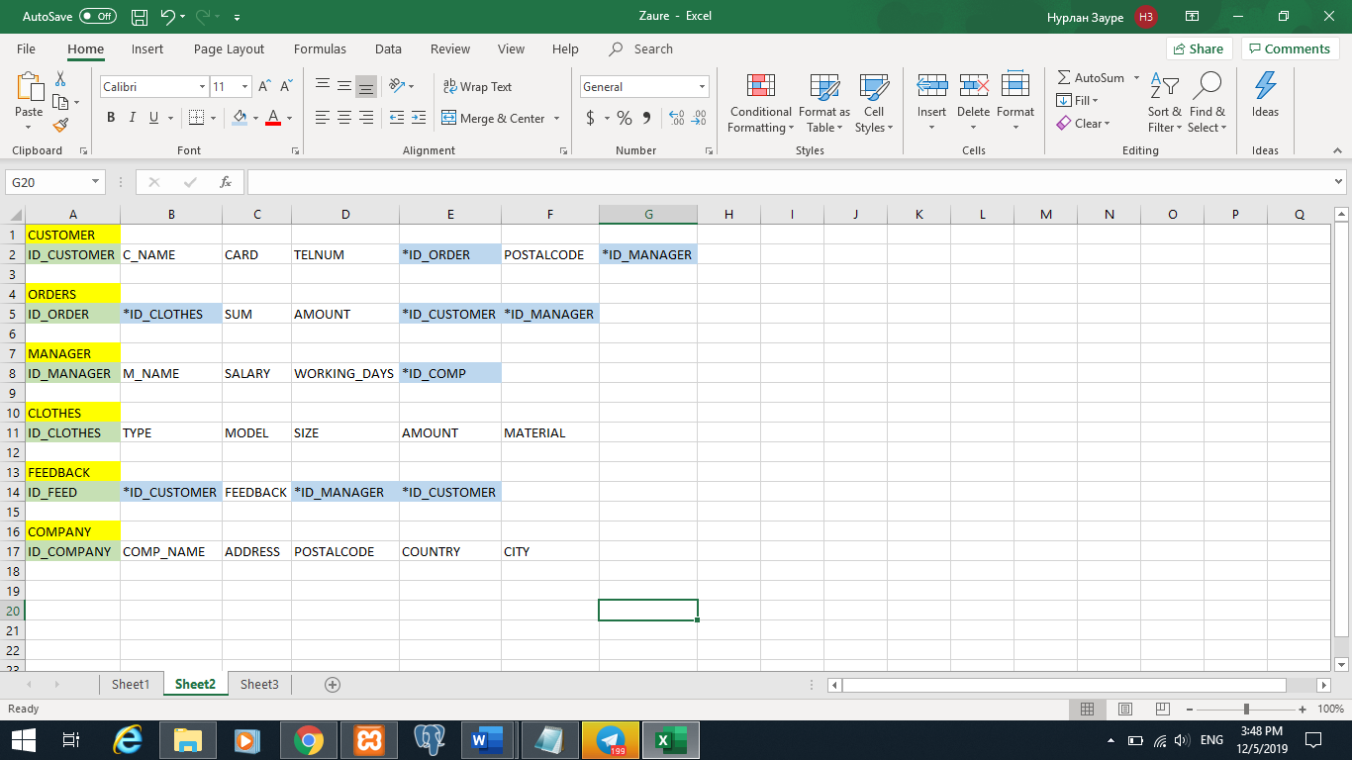

In 2 NF we got rid of partial functional dependence, but we still face some troubles.

Update: we can’t change information in feedback because we will have to change it everywhere.

Delete: we will have to delete everything if we want to delete some information in feedback.

Insert: we will have to insert information to other tables in order to add information to feedback table.

Third Normalization

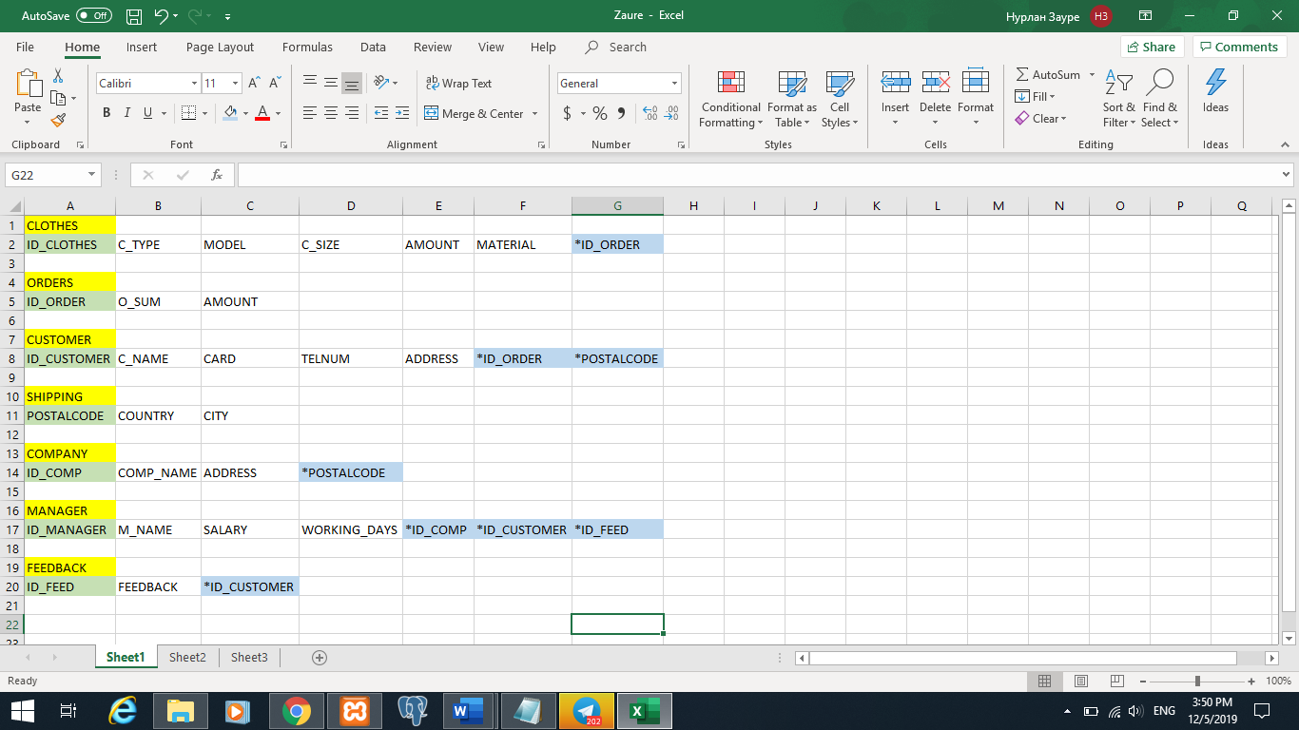

Data is normalized because we got rid of transitive fuctional dependence. Therefore, there is no data redundancy.

1. select distinct material

from clothes;

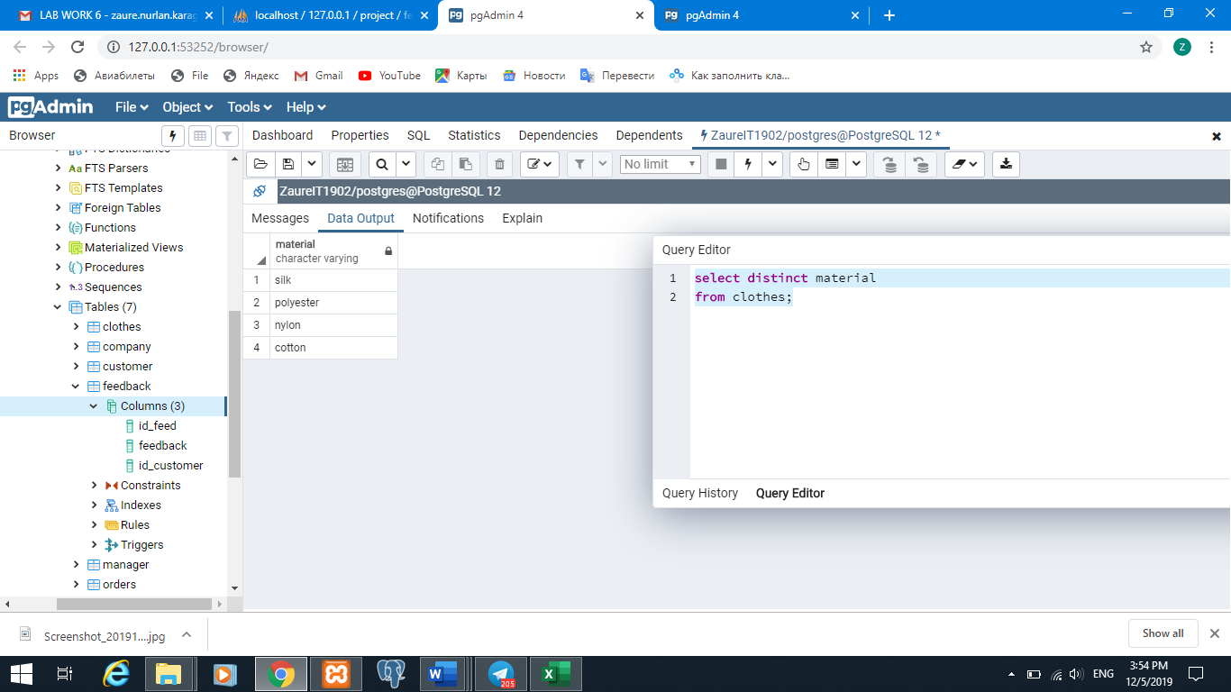

select * from clothes

group by id_clothes having (amount >10);

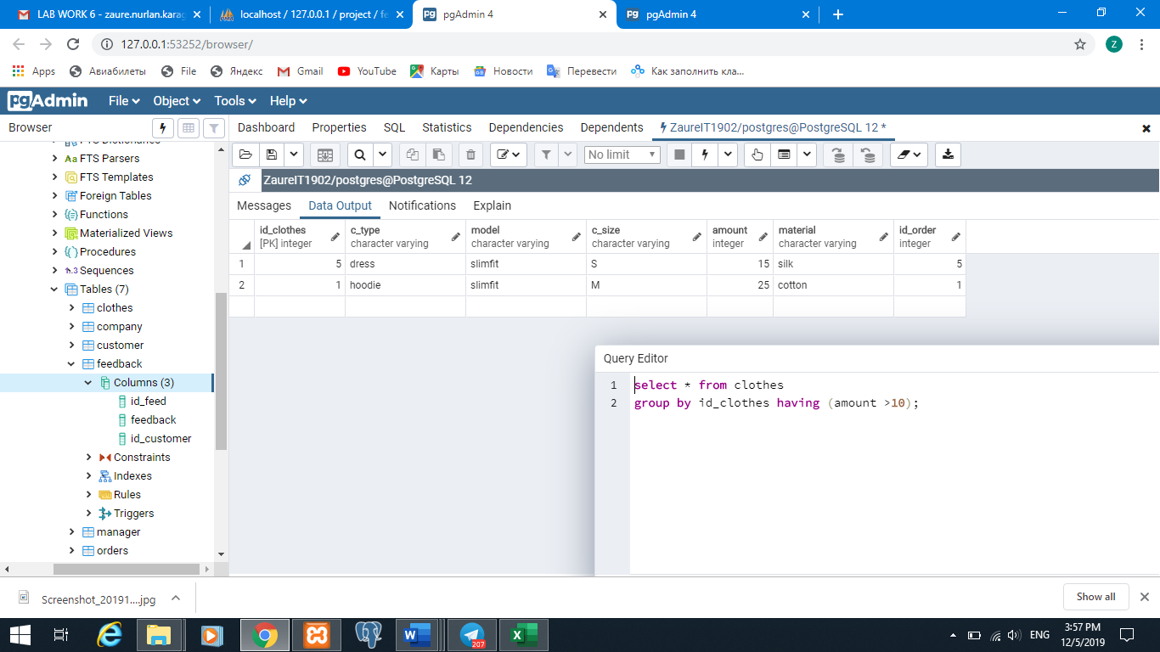

select * from clothes

where c_size = 'M' or c_size = 'S';

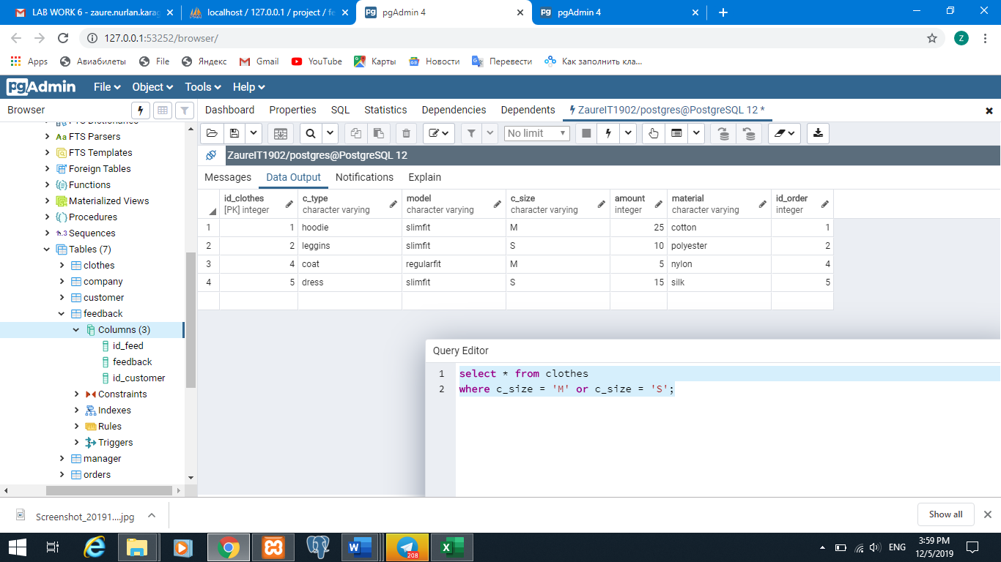

select * from clothes

where amount >= 10 and amount <= 20;

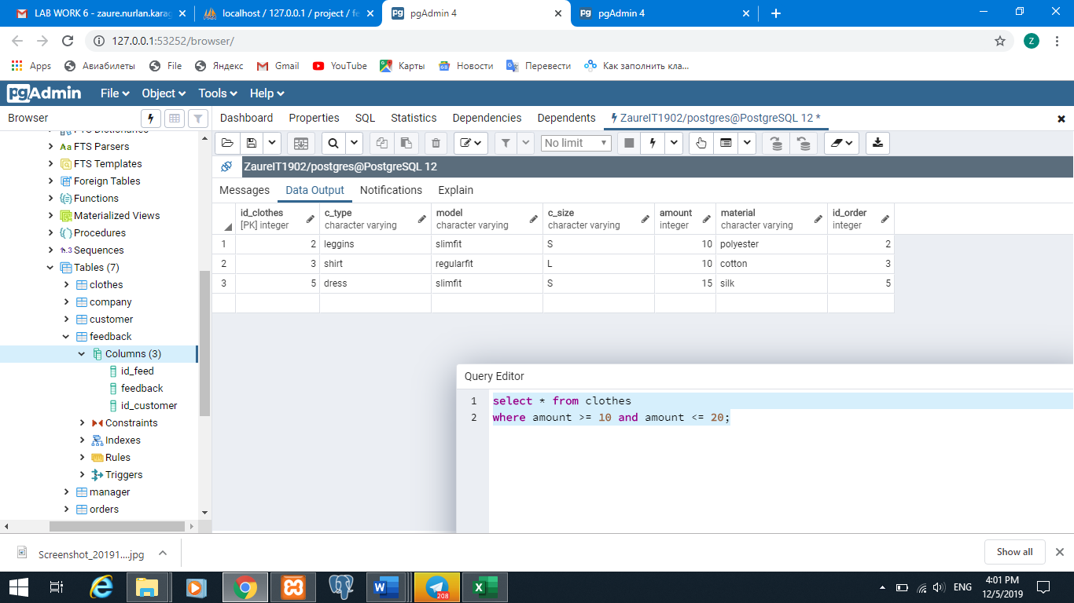

select * from clothes

where amount between 5 and 20;

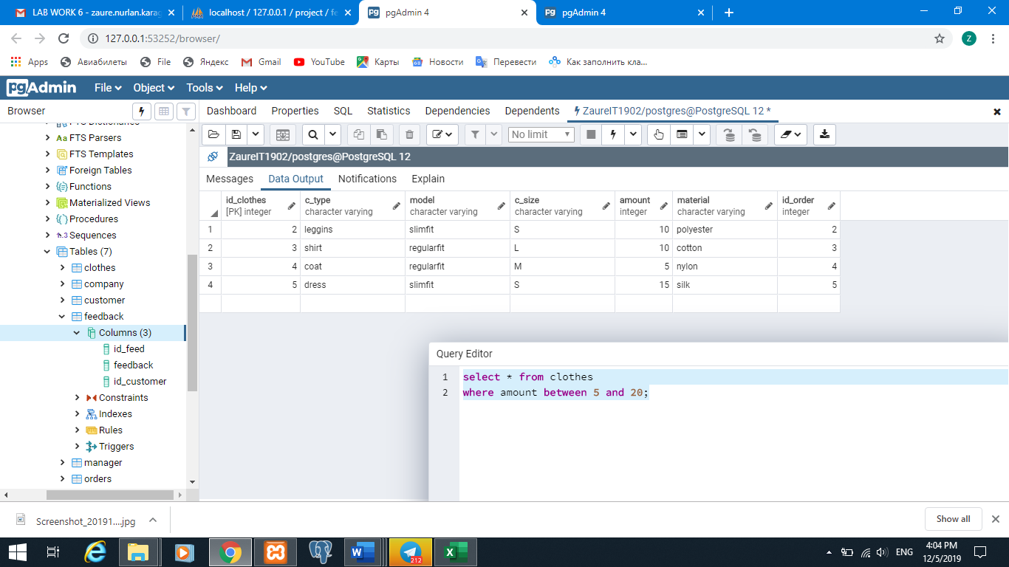

select * from clothes

where material in ('cotton', 'silk');

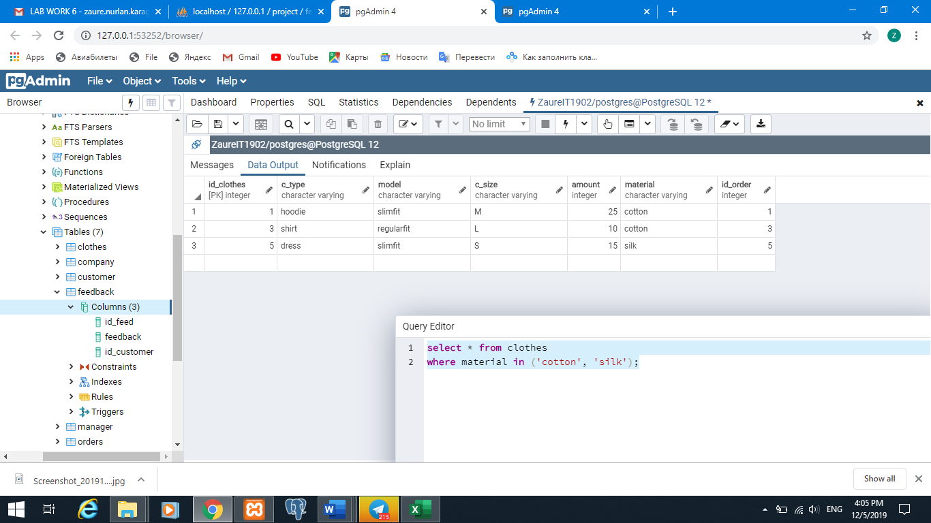

select * from manager

where m_name like '%i%';

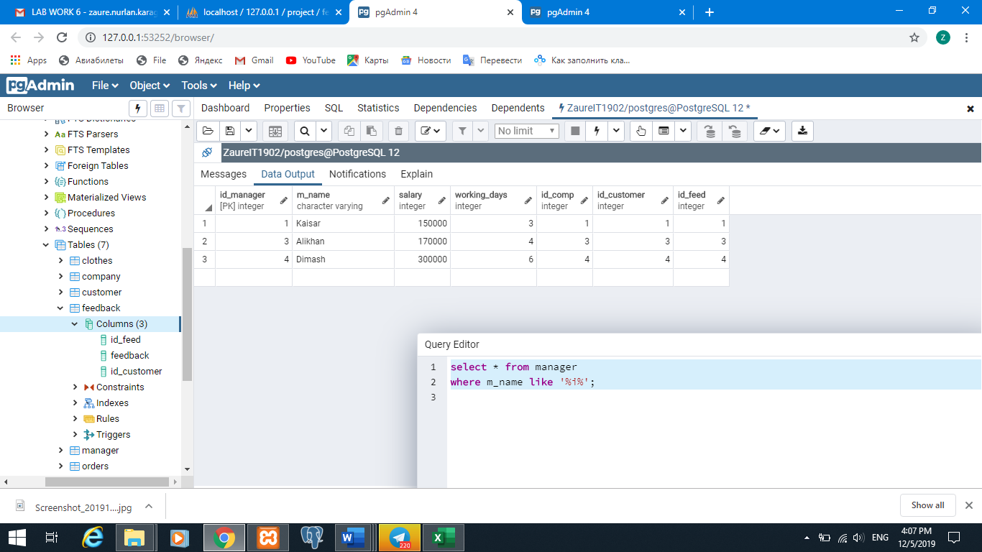

select m_name, length(m_name) as Length_of_Managers_name

from manager;

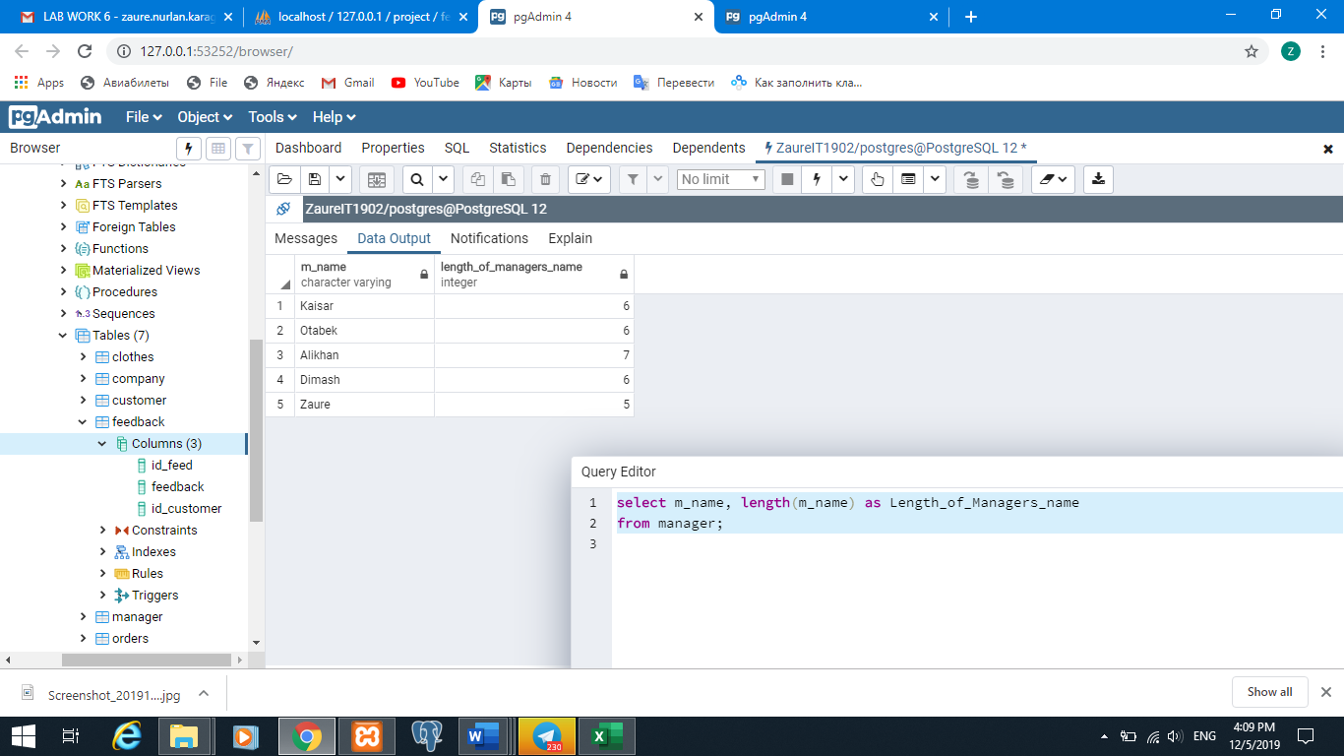

select count(id_manager), sum(salary), min(salary), max(salary), avg(salary)

from manager;

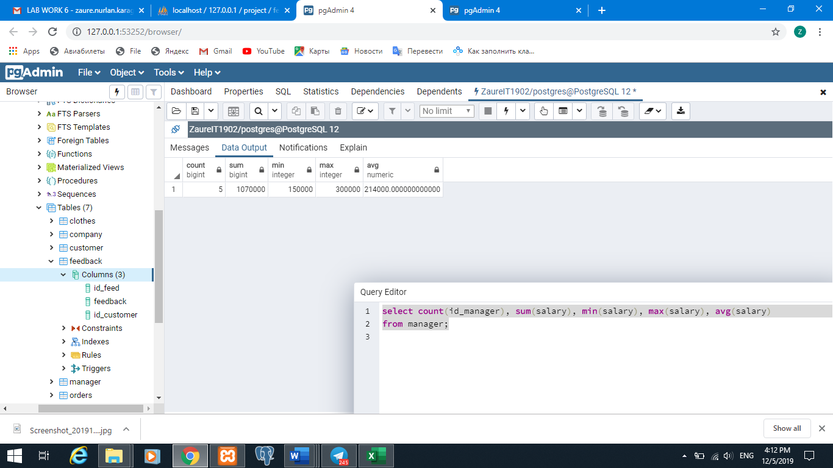

select c.c_name, c.telnum, o.amount

from orders o

right join customer c

on o.id_order=c.id_order

where o.o_sum > 1000;

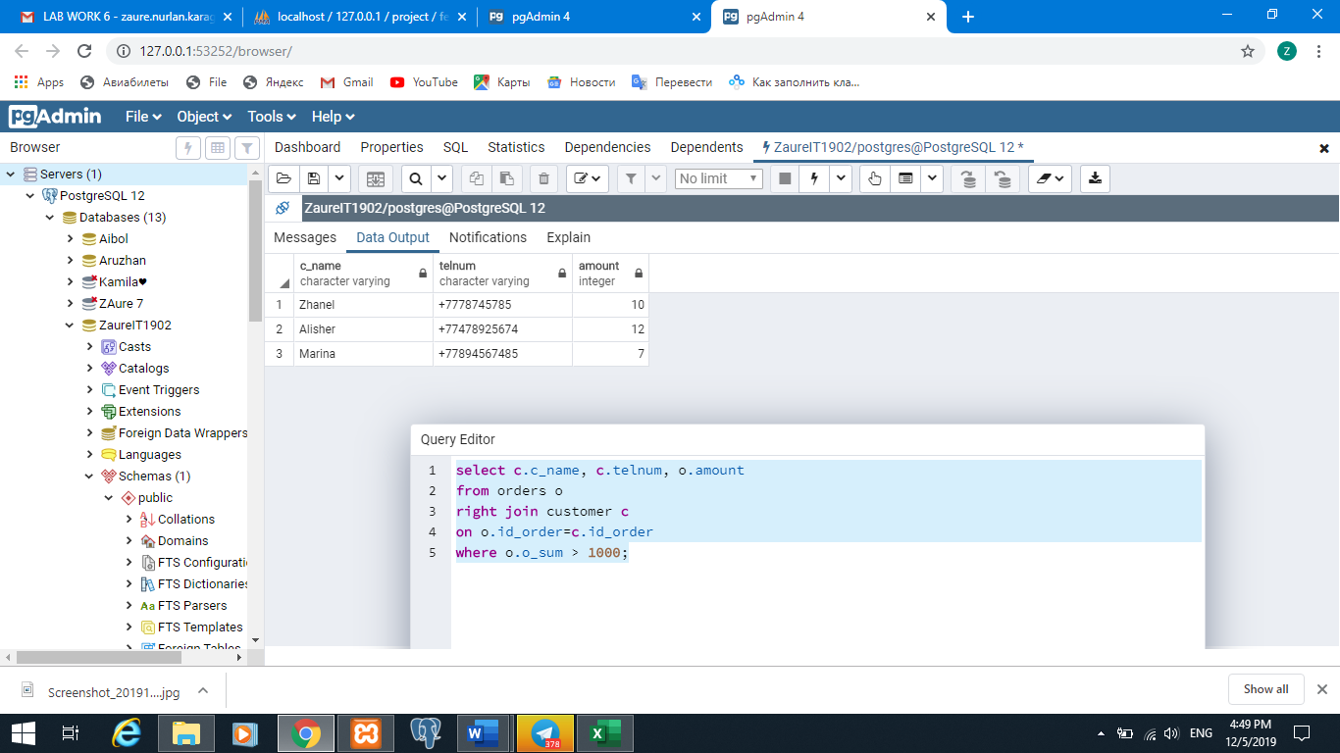

select m.m_name, m.salary, m.working_days, c.comp_name

from manager m

left join company c

on m.id_comp=c.id_comp

where salary >= (select avg(salary) from manager);

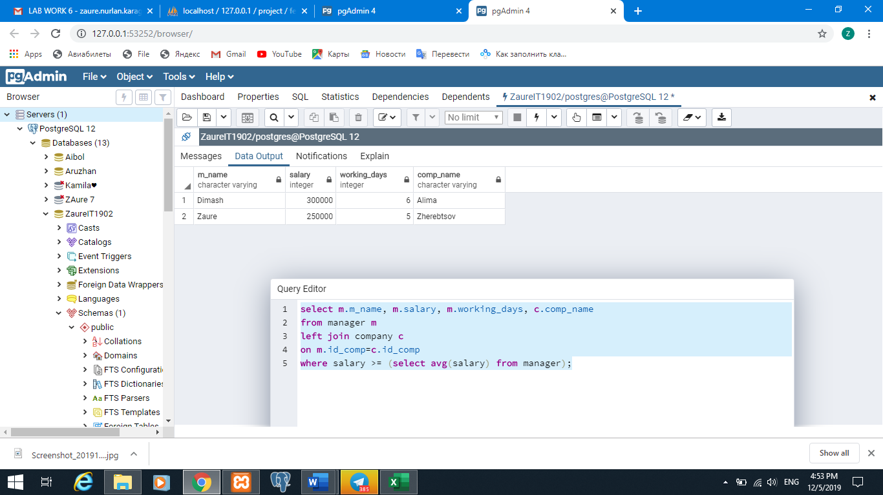

select f.feedback, m.m_name, m.working_days

from feedback f

left join manager m

on f.id_feed=m.id_feed

where salary >= (select avg(salary) from manager);

select c.c_name, f.feedback, m.m_name, m.working_days

from customer c

inner join feedback f

on c.id_customer=f.id_customer

left join manager m

on f.id_feed=m.id_feed

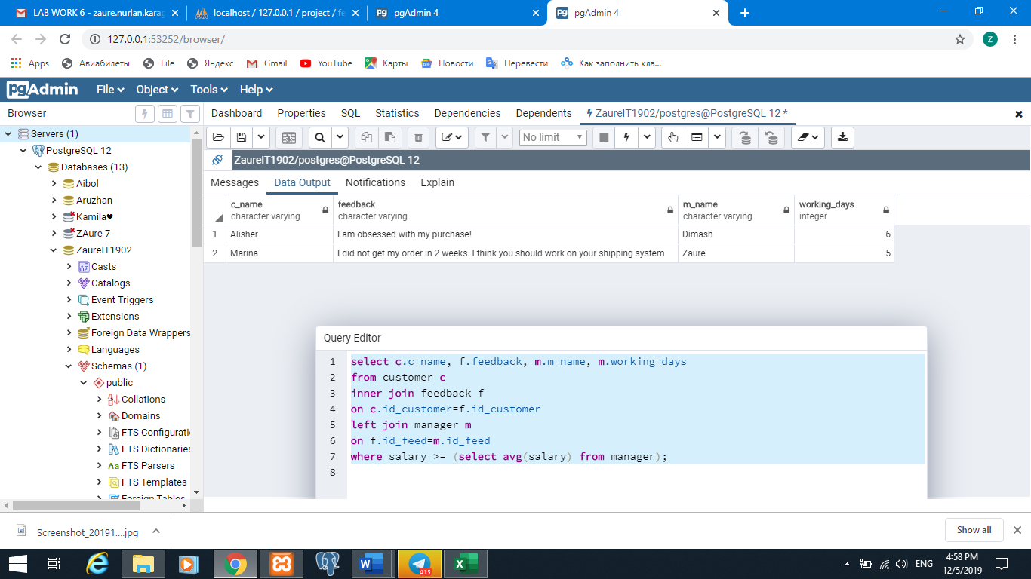where salary >= (select avg(salary) from manager);

1. select * from clothes

where material in ('cotton', 'silk');



select * from manager

where salary > any(select salary from manager);

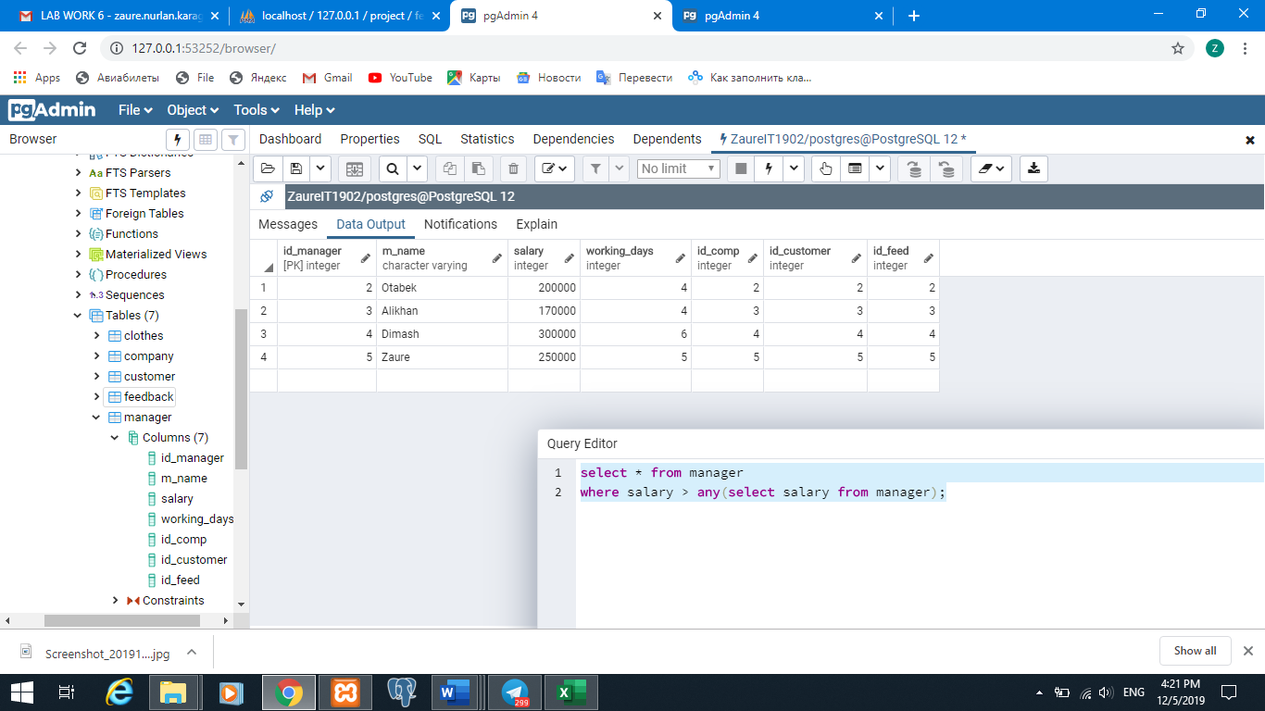

select * from manager

where salary >= all(select salary from manager);

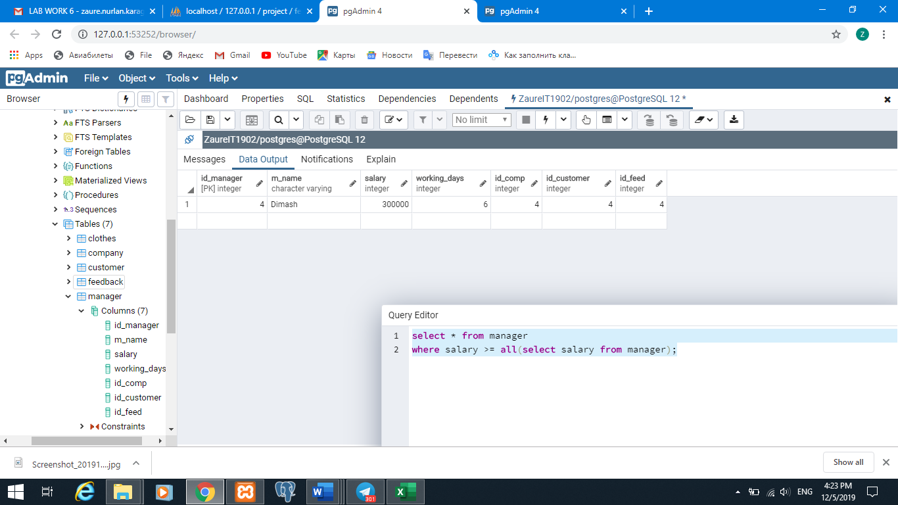

select id_order, o.amount from orders o

where exists (select c.c_type from clothes c

where o.id_order=c.id_order and c.amount <15);

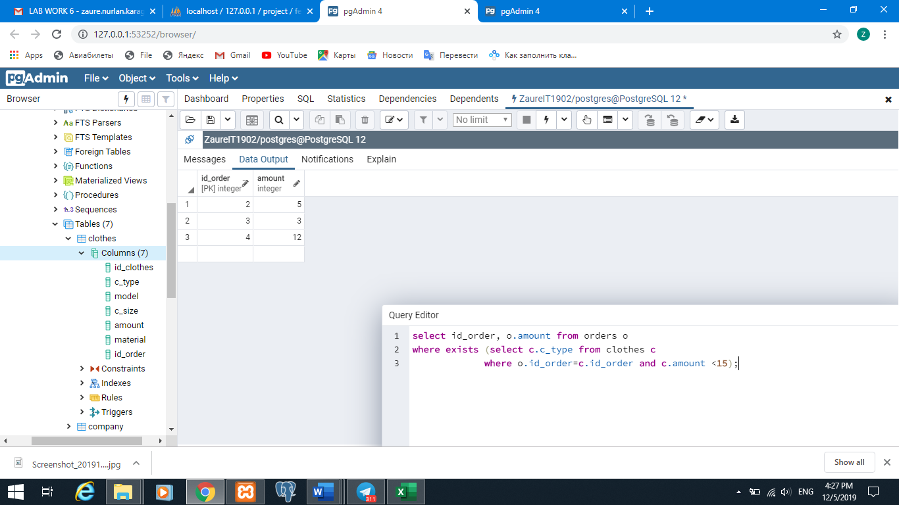

select id_order, o.amount from orders o

where not exists (select c.c_type from clothes c

where o.id_order=c.id_order and c.amount <15);

